DataRx Open Source Projects

<http://a2zdb.io> | <http://datarx.org> | <http://datarx.io>

# OPEN SOFTWARE DEVELOPMENT KIT

**OVERVIEW:**

DataRx is a new open source software project initiative that supports full stack web tier software development. The three core areas DataRx projects will address include the data layer, the business layer and the user interface layer using enterprise class patterns and taxonomy object models. Core features include portal management, user provisioning, identity management, content management system as well as various logging and dashboard strategies that will provide you a service oriented architecture with open data taxonomies, code generator factories, dynamic user experience and interface management. Call stack architecture uses abstract data factories that support all popular database platforms including hybrid data models that exist in both relational and dimensional form. Code generators will provide API’s for JavaScript, C# .Net, ASP.NET MVC, Java, ColdFusion, (TBD: React, Meteor, Go, Python+R, etc….). All of the taxonomy can be socialized and geo tagged

Eventually, the culmination of these projects with associated plugins will be applied toward an “Underground Social Media” platform that has no corporate strings attached and is based on negotiated privacy policies (I am a huge privacy advocate). Imagine a private social media network for you, your family and close friends that can be used as a launching point for your online media profile that you have complete control of. If your more interested I can fill you in.

**DOCUMENT FOCUS:**

The focus of this document addresses the SDK. This SDK exists in real life but is not ready for an open source project as is getting written from the ground up to support multiple programming languages. Right now it is only designed for C#, ASP.NET and JavaScript. I am making the factory pluggable. The next pages are where I plan to implement w2ui. In fact, your library will play a huge role when CMS is connected to the code generator. That said, the following screen captures demonstrate how far I am and how I plan to use your library. At the end I have added additional screen captures to demonstrate my prototype use of w2ui. I will need to add some additional functionality as well as state but I would like to talk to you about this as clearly you are an expert and can offer insight into the direction I am actively moving with your tools.

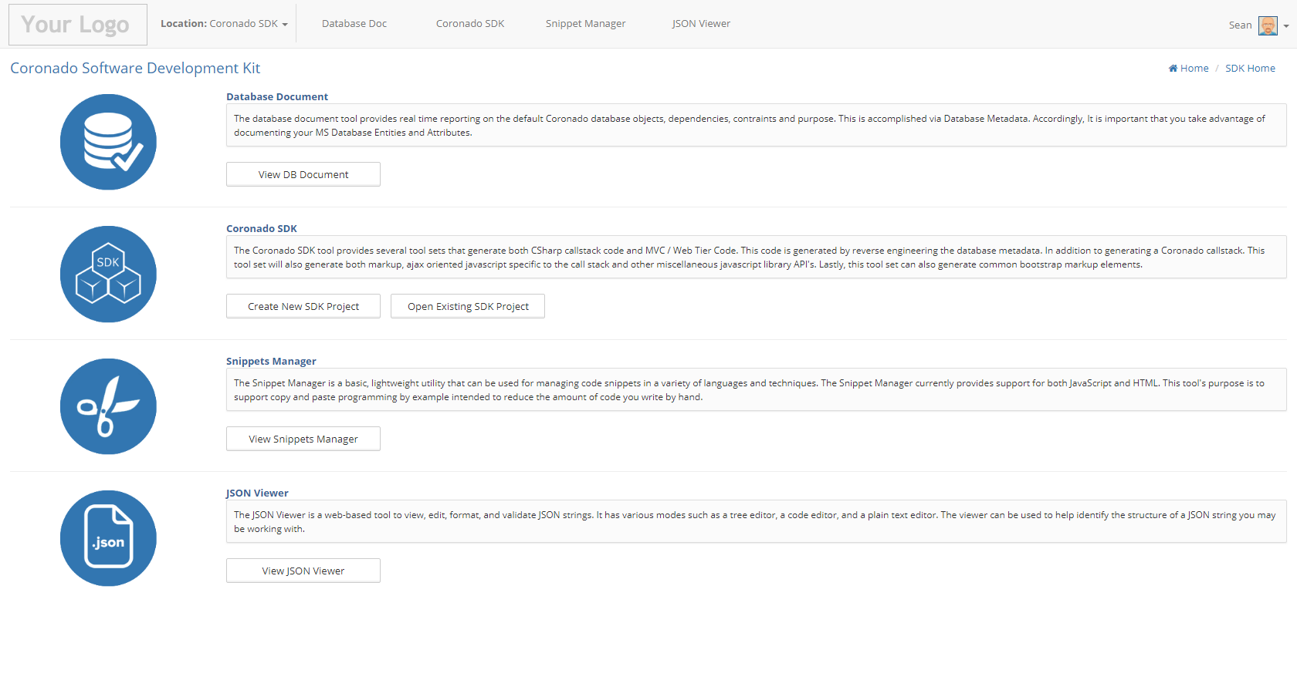

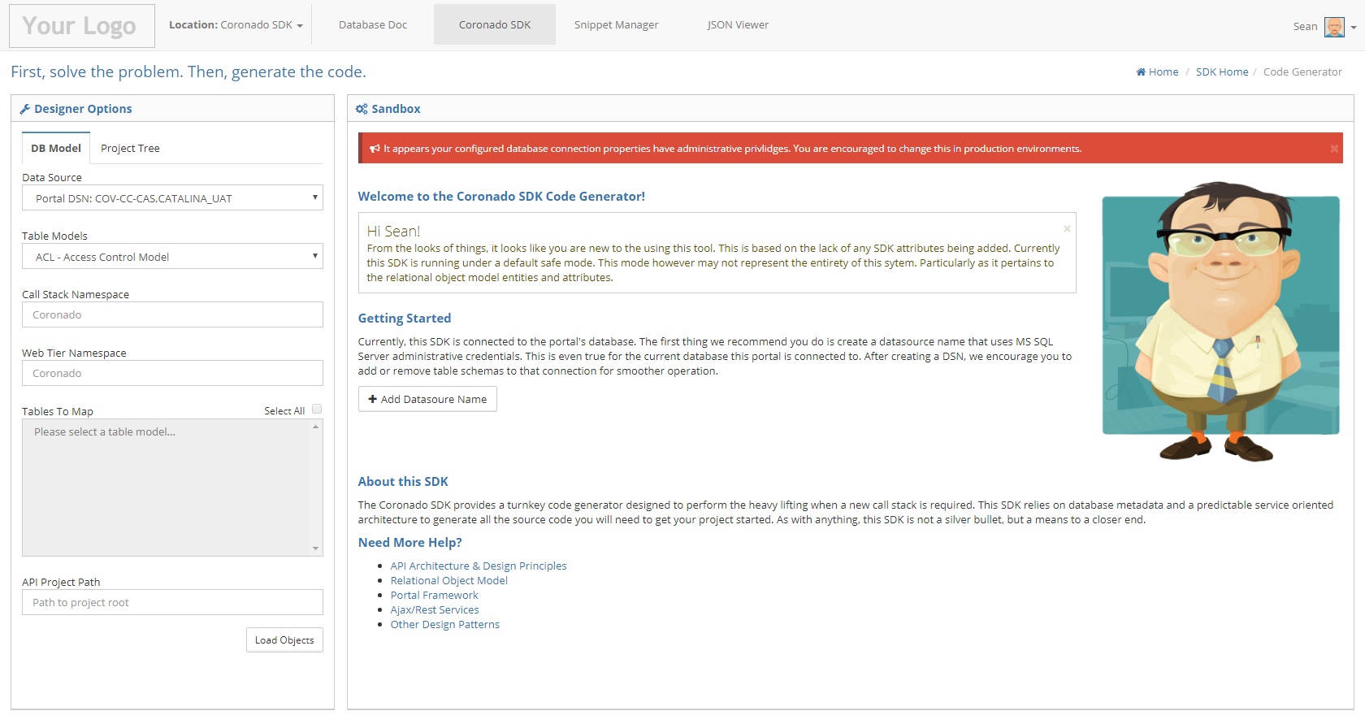

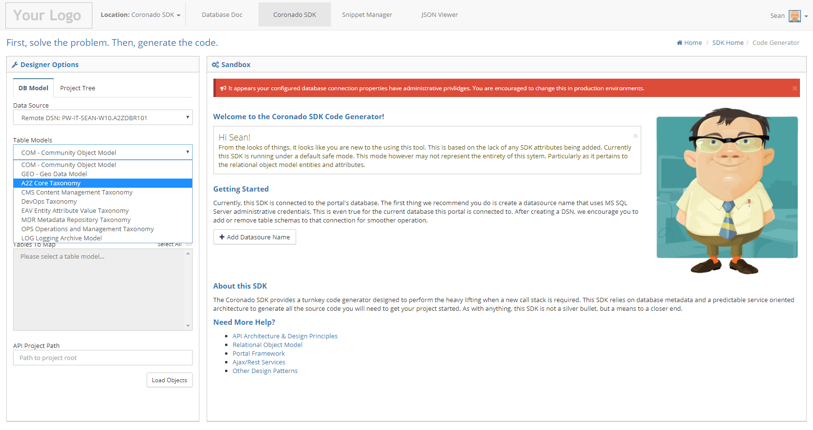

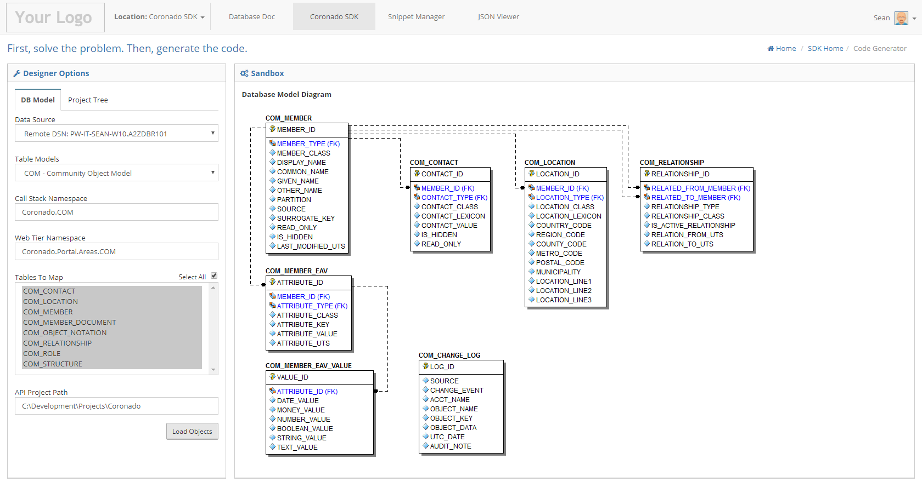

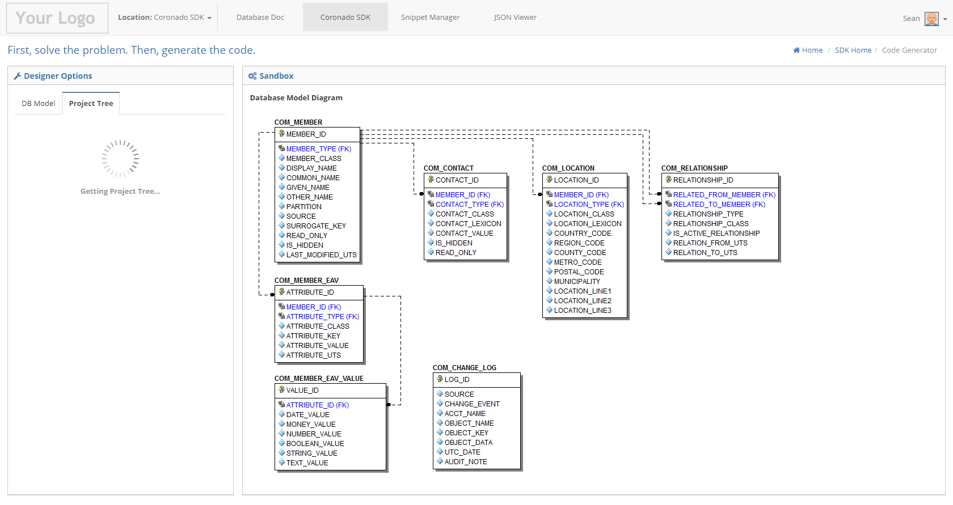

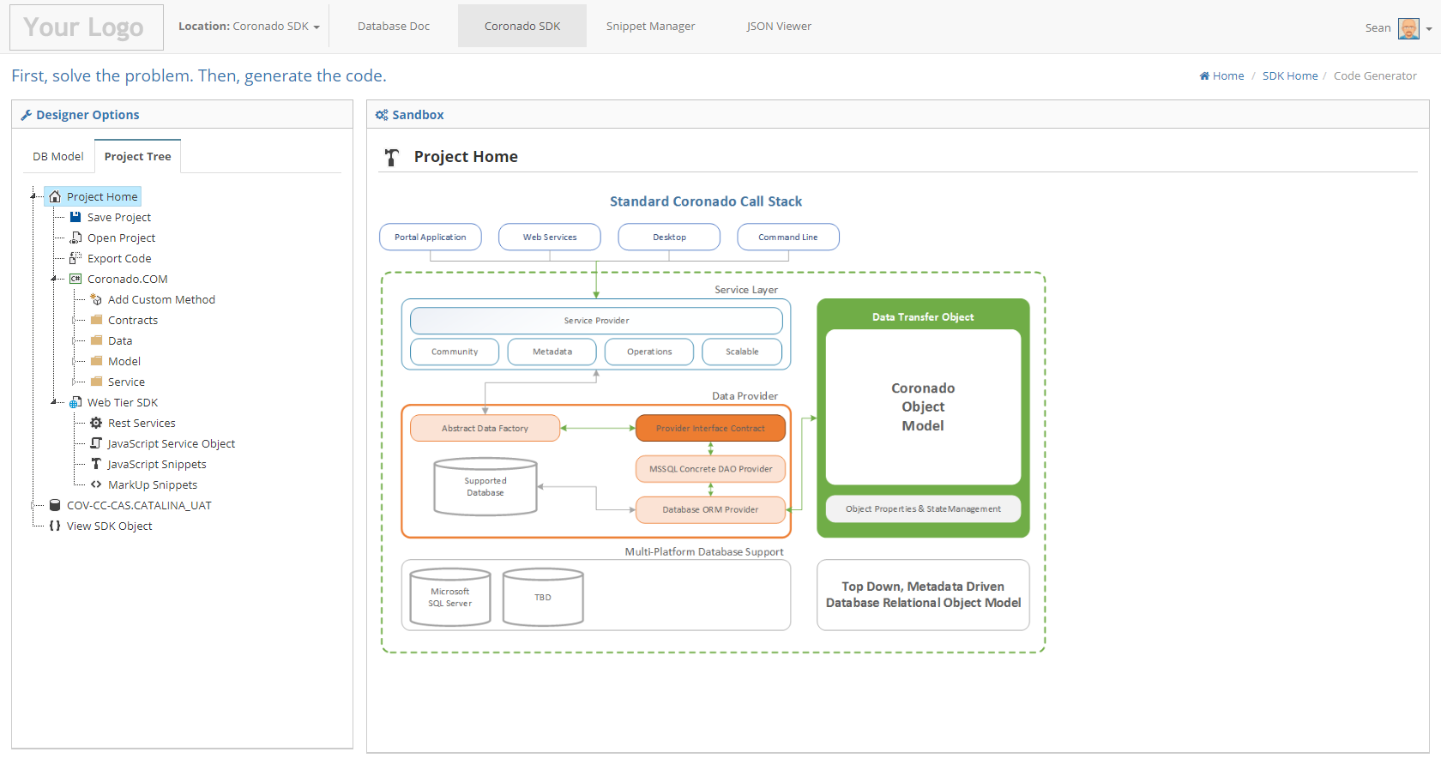

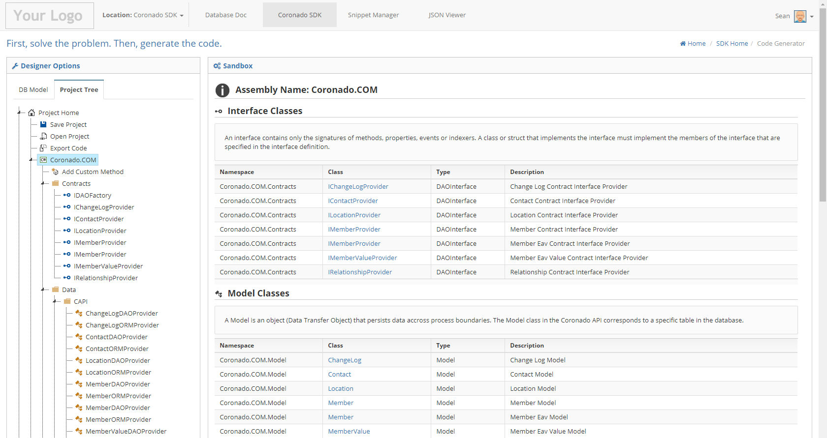

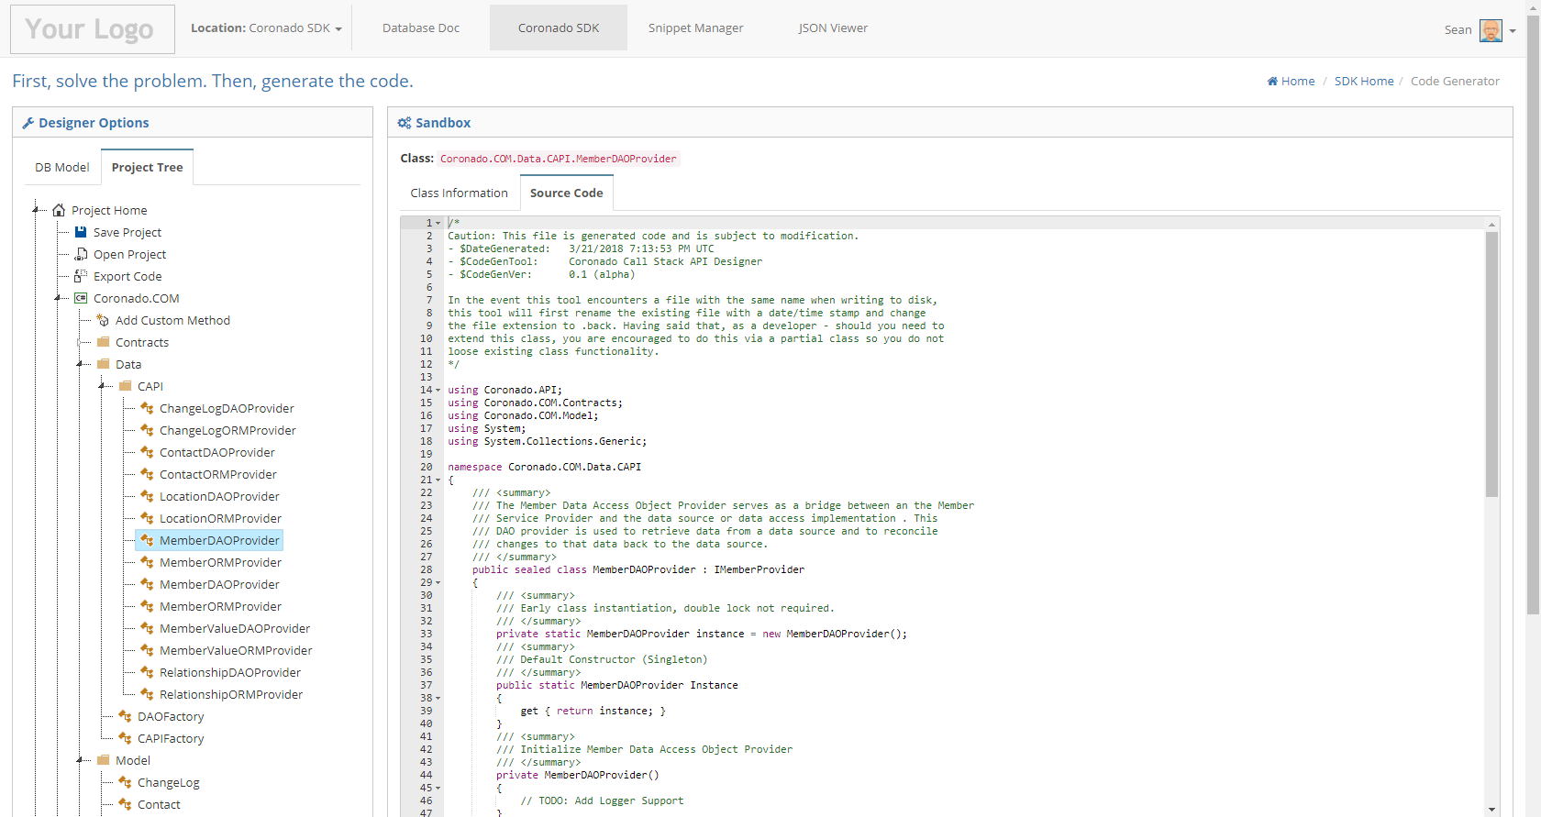

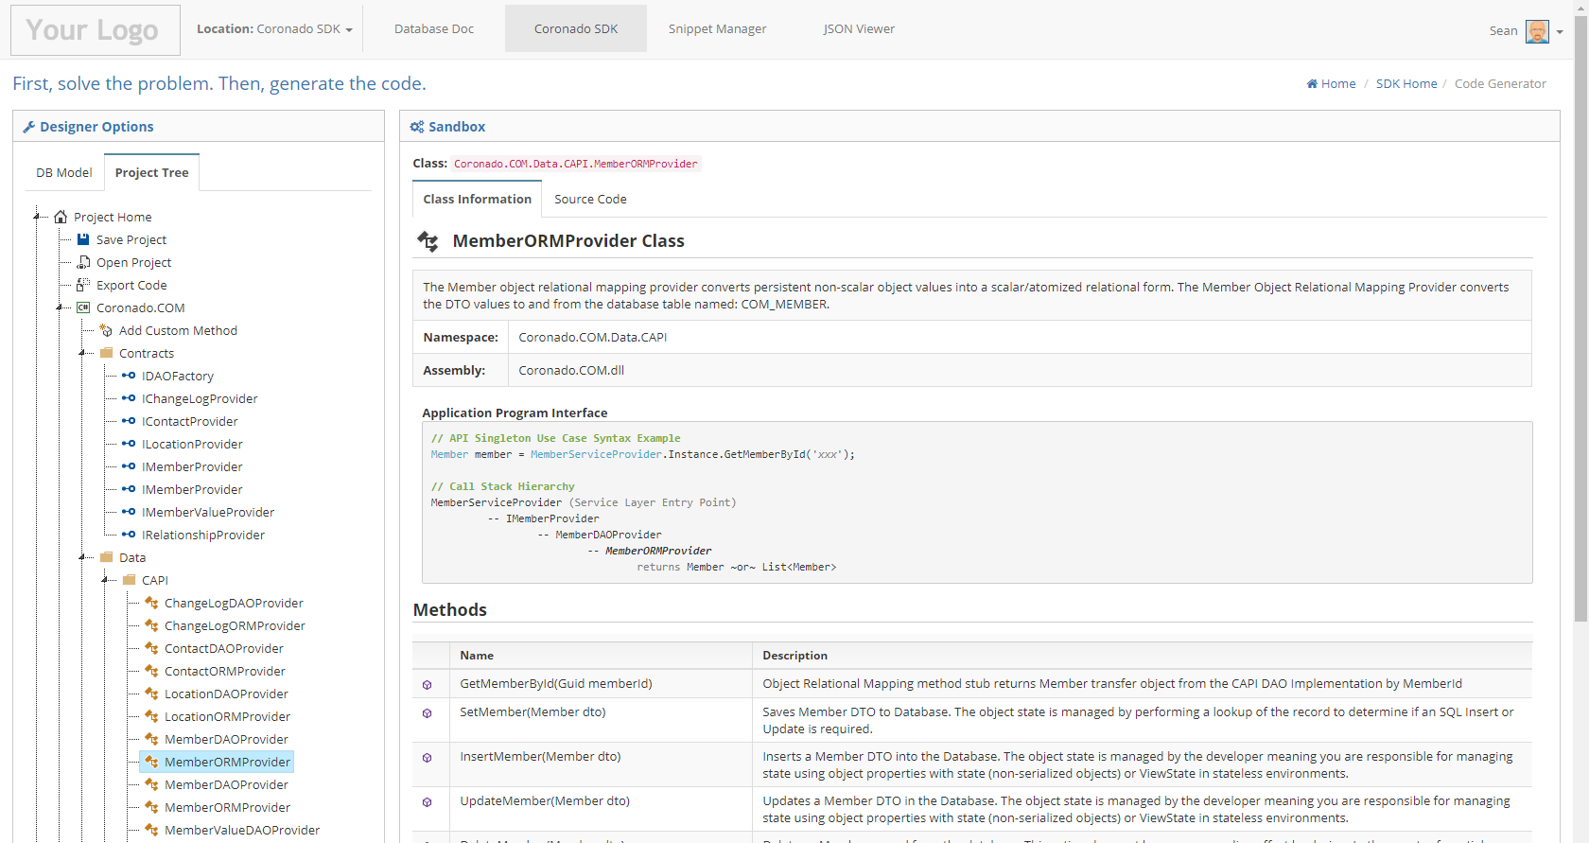

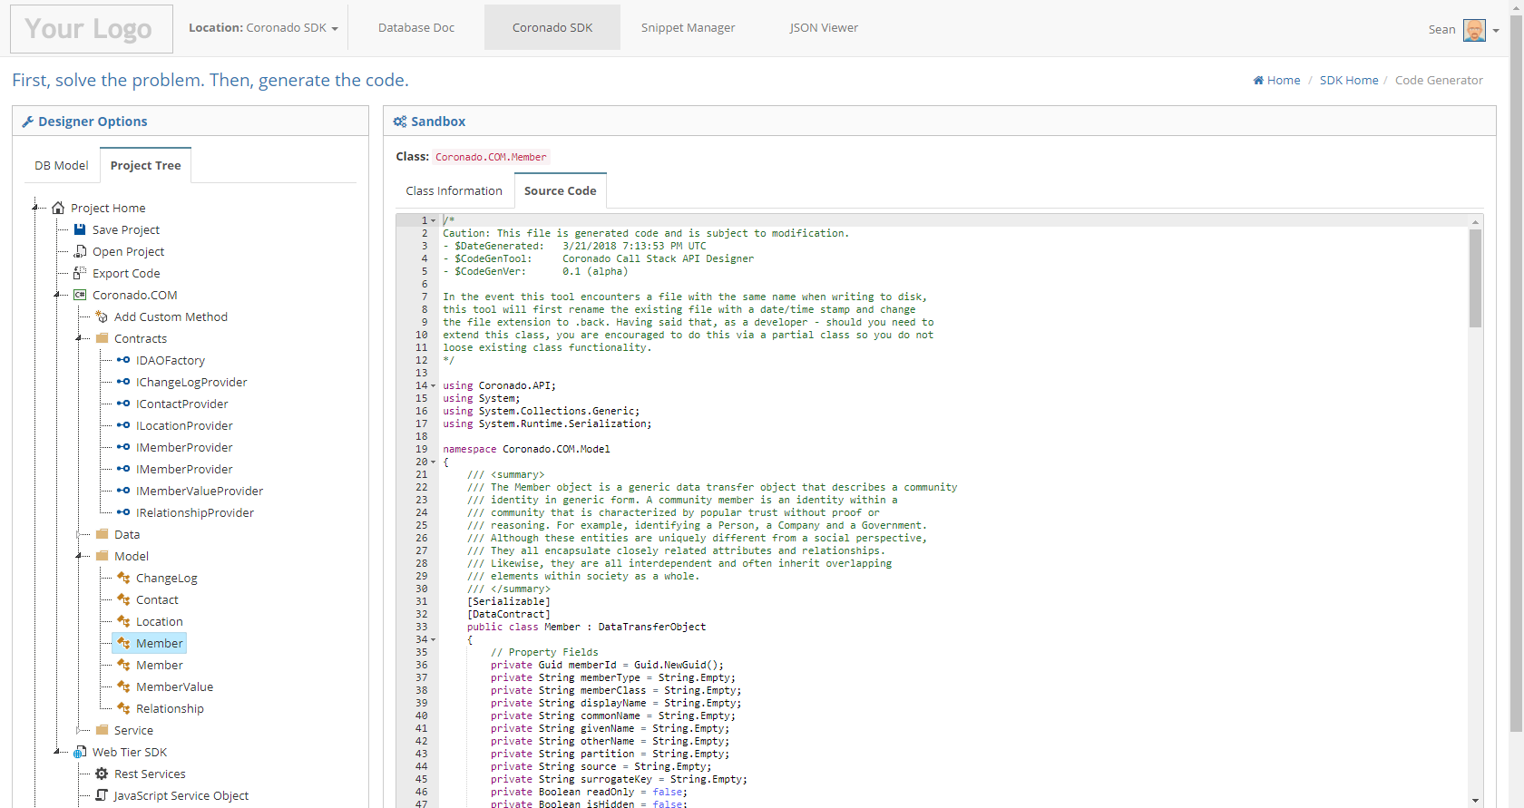

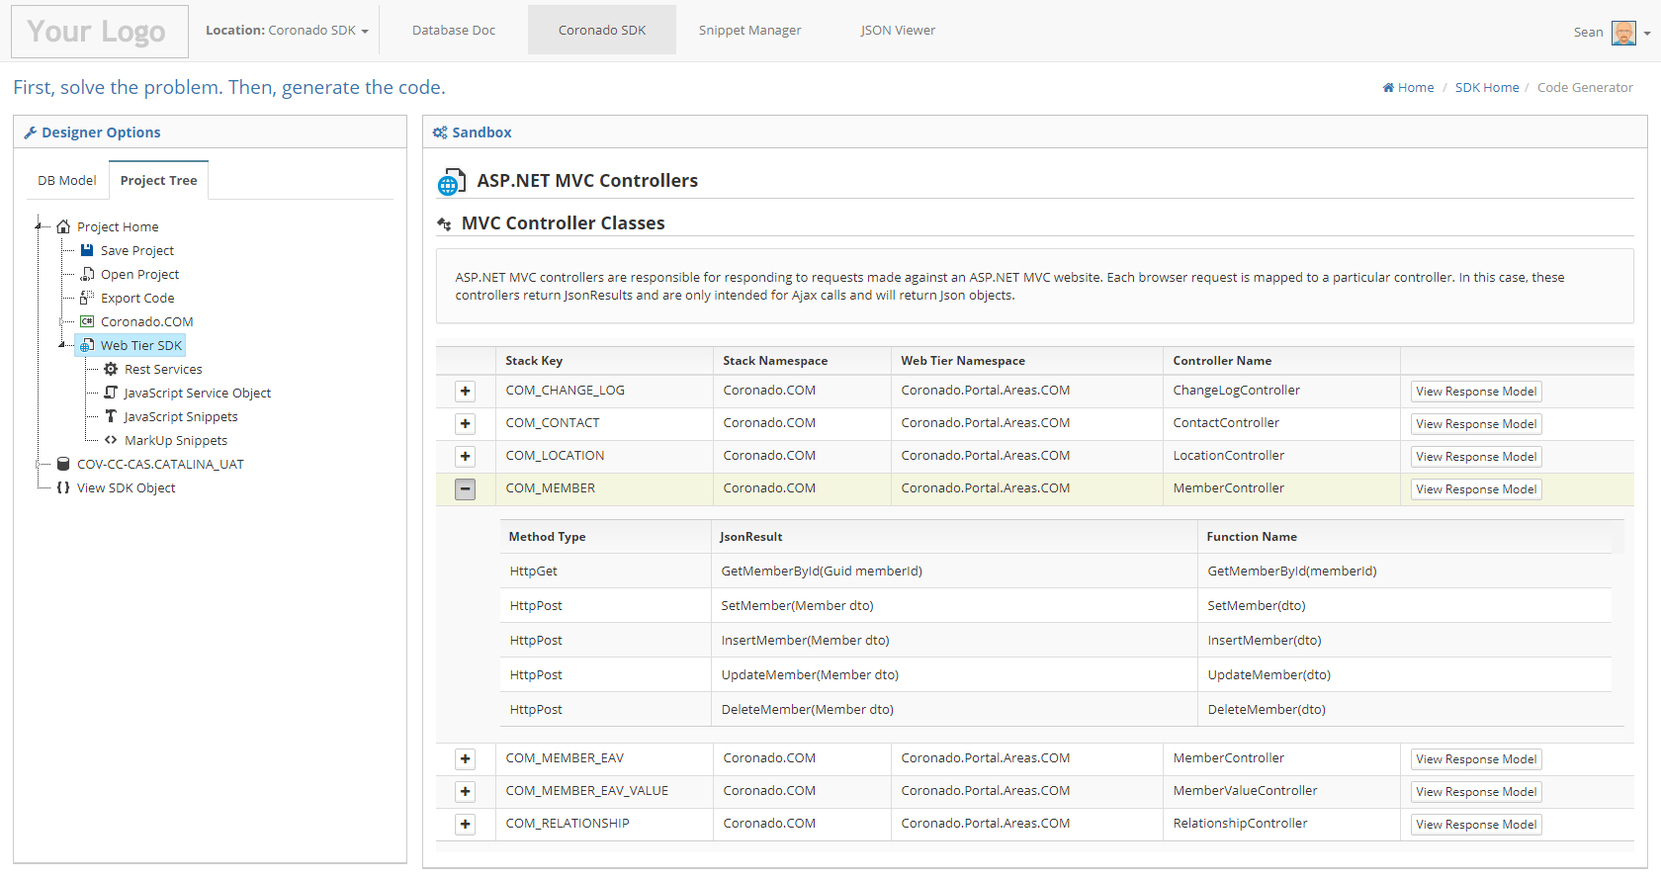

12

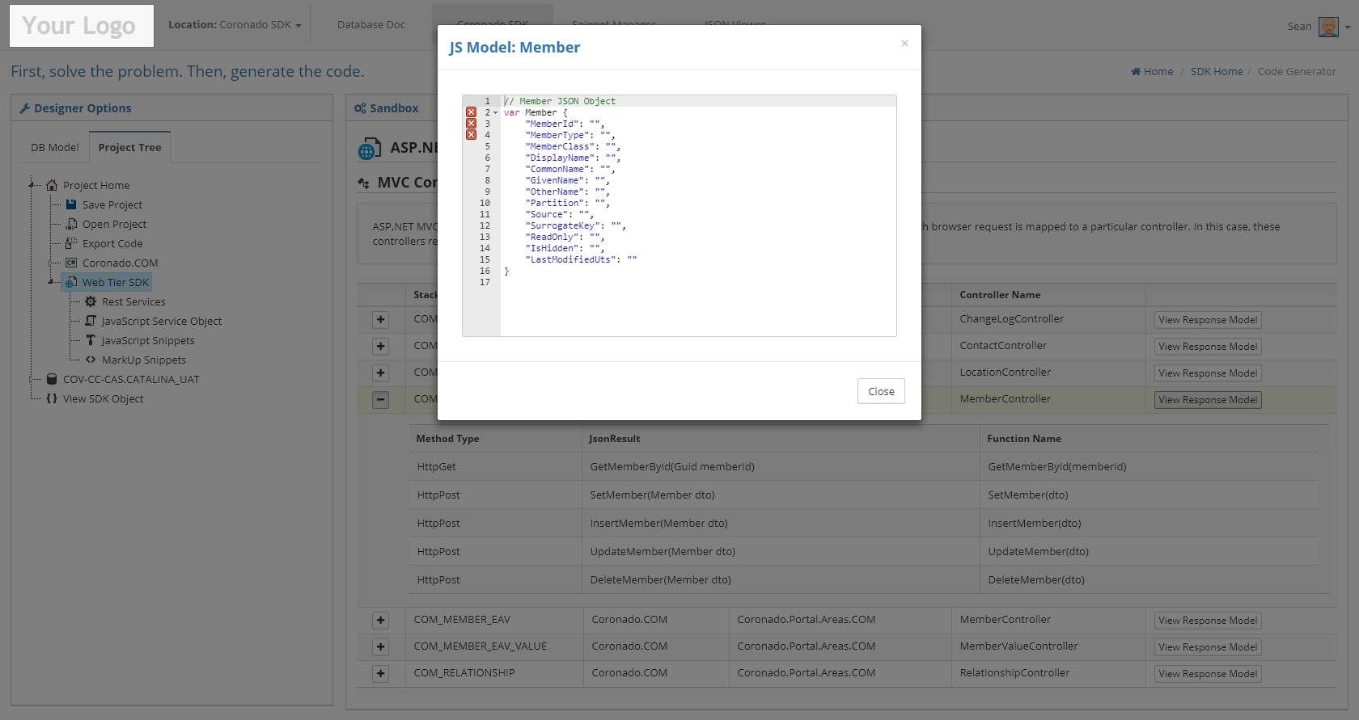

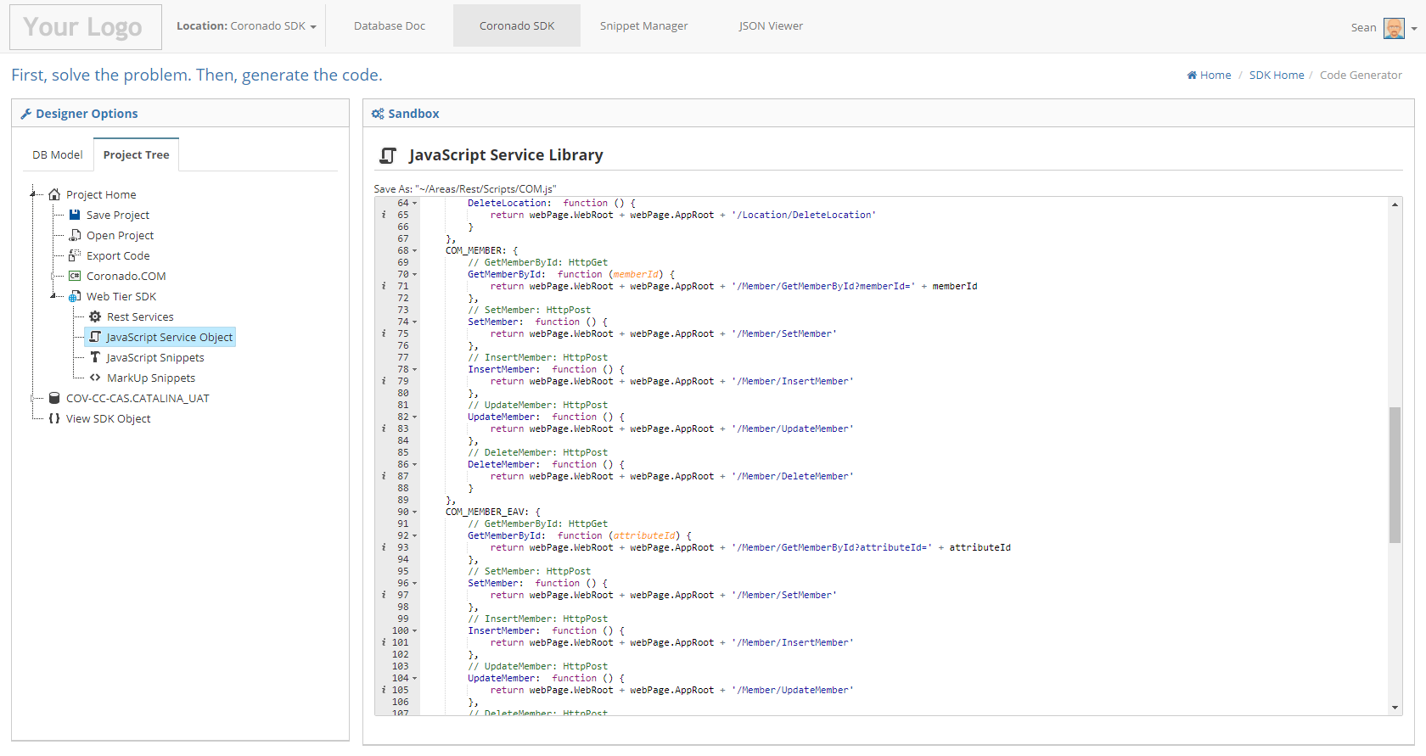

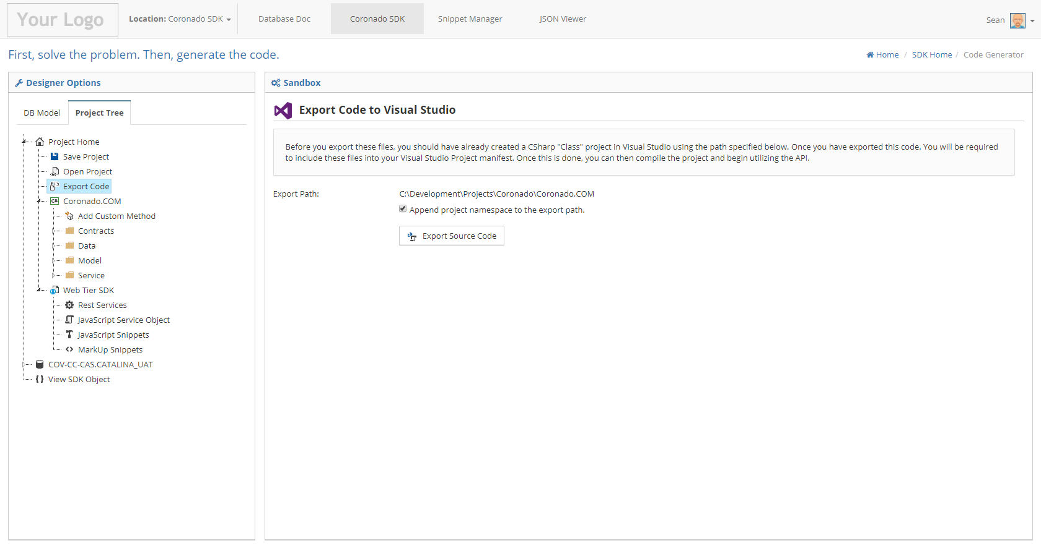

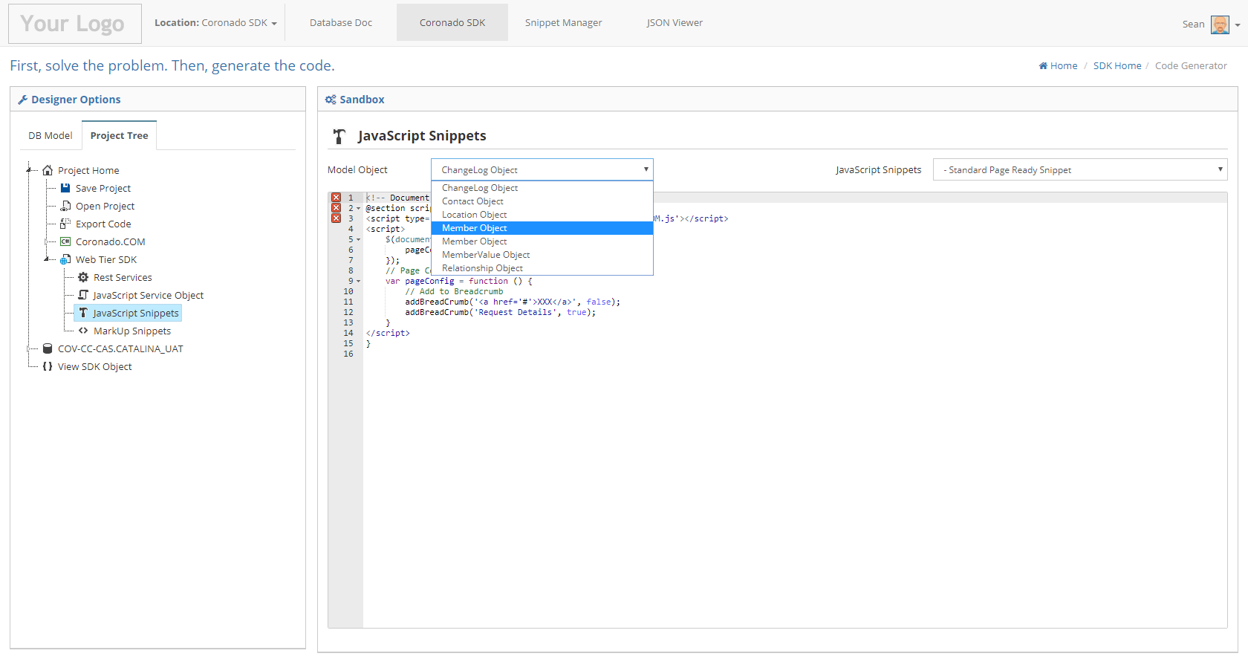

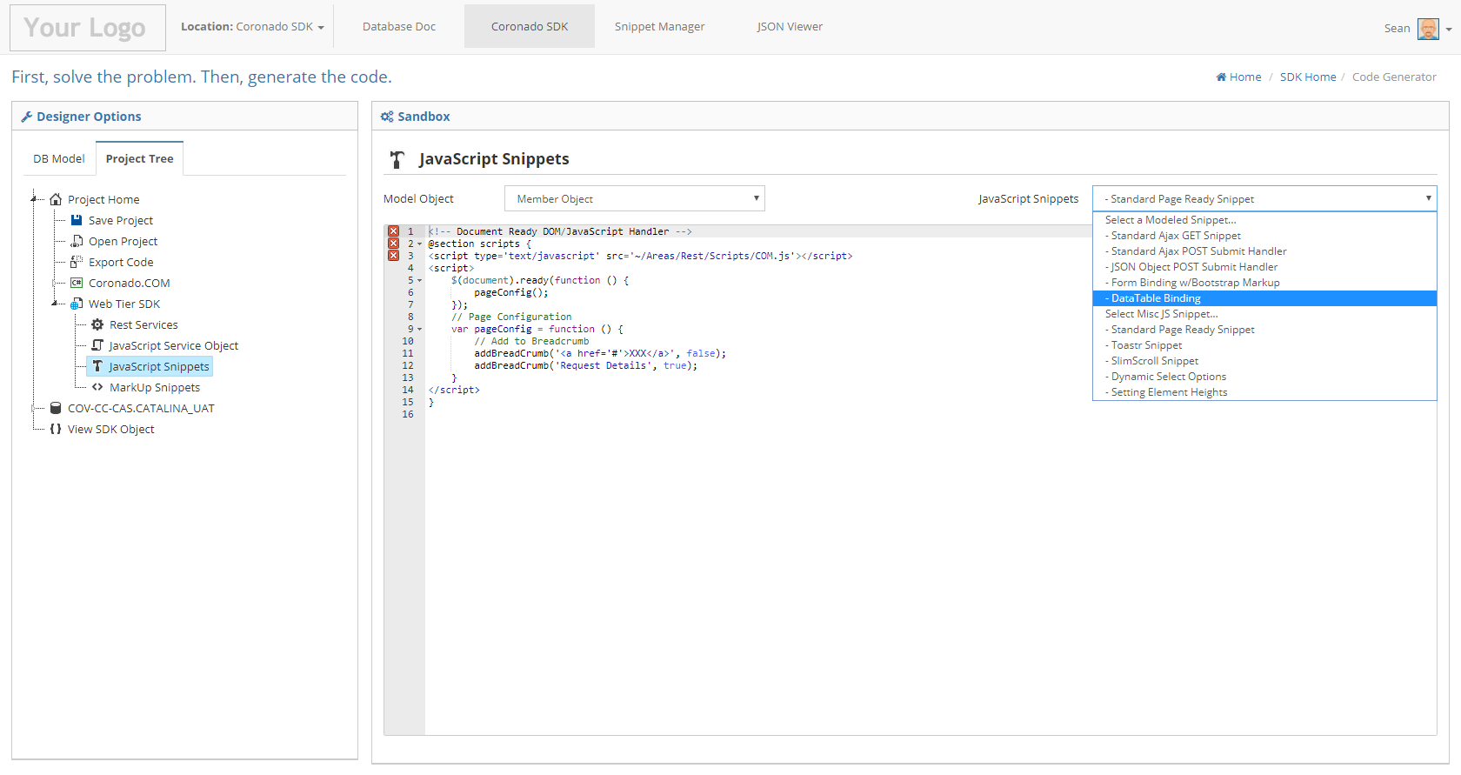

16

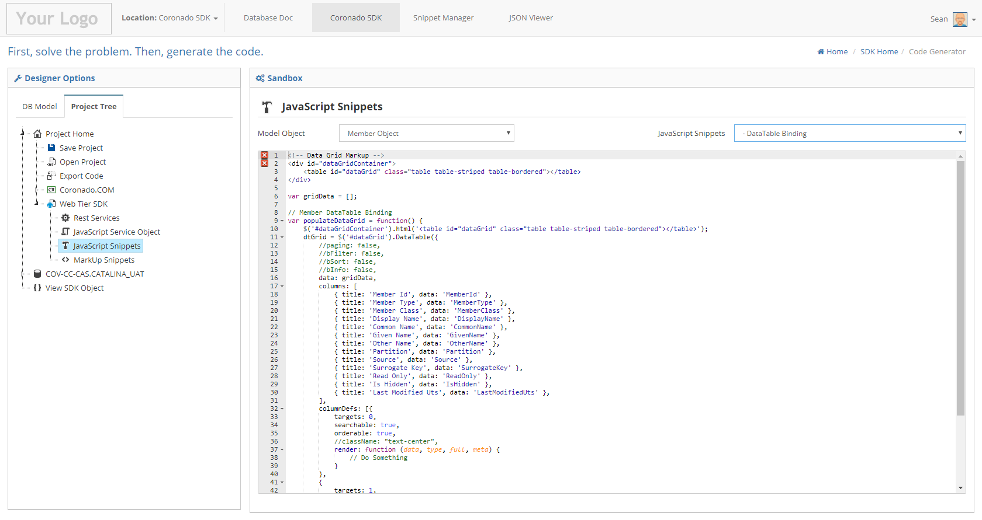

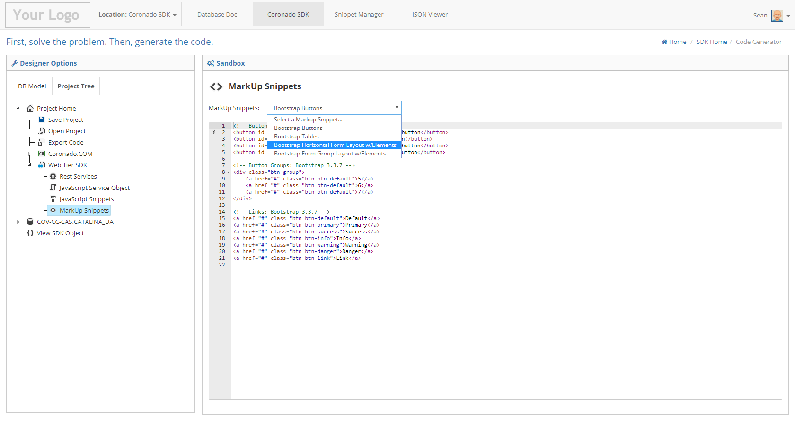

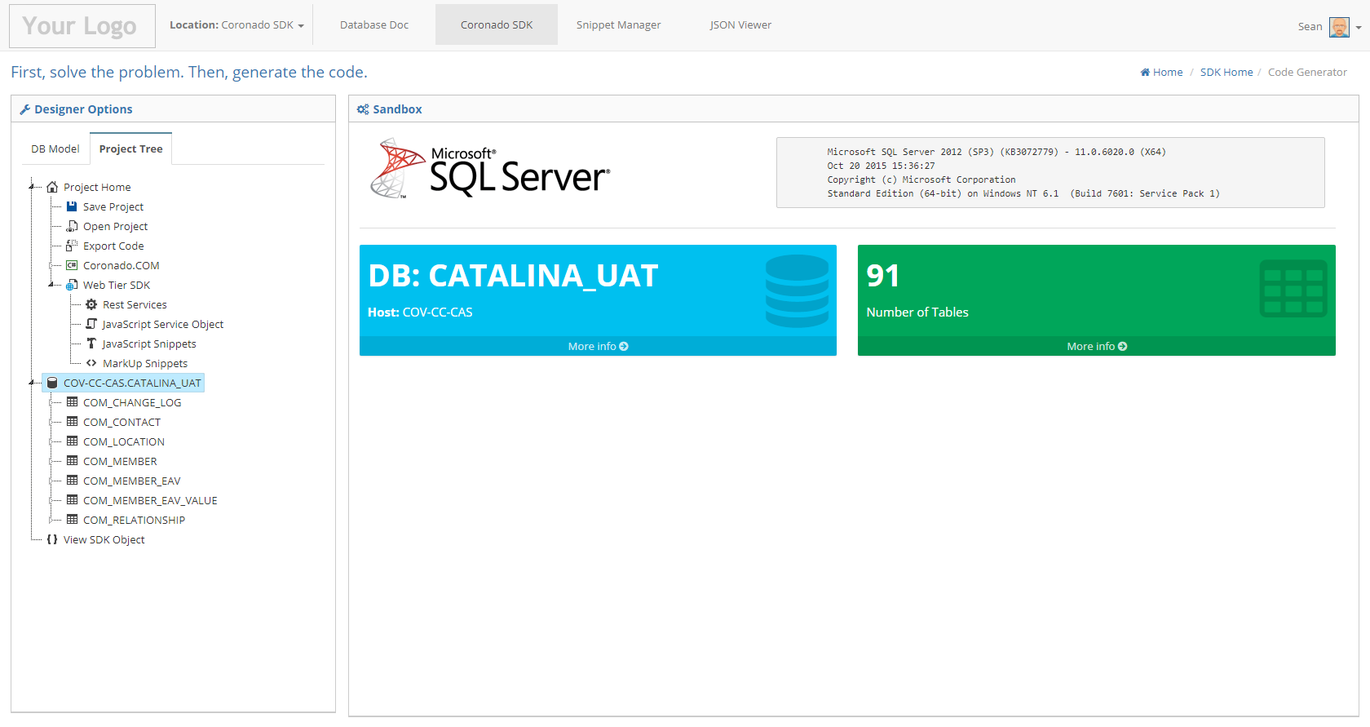

19

